**Estimated time to complete this lab: 30 minutes. Please follow the instructions to complete the hands-on. Each instruction expect a command for the Git Bash.**

**1. Verify if master is in clean state.**

**2. Create a branch “GitWork”. Add a file “hello.xml”.**

**3. Update the content of “hello.xml” and observe the status**

**4. Commit the changes to reflect in the branch**

**5. Switch to master.**

**6. Add a file “hello.xml” to the master and add some different content than previous.**

**7. Commit the changes to the master**

**8. Observe the log by executing “git log –oneline –graph –decorate –all”**

**9. Check the differences with Git diff tool**

**10. For better visualization, use P4Merge tool to list out all the differences between master and branch**

**11. Merge the bran to the master**

**12. Observe the git mark up.**

**13. Use 3-way merge tool to resolve the conflict**

**14. Commit the changes to the master, once done with conflict**

**15. Observe the git status and add backup file to the .gitignore file.**

**16. Commit the changes to the .gitignore**

**17. List out all the available branches**

**18. Delete the branch, which merge to master.**

**19. Observe the log by executing “git log –oneline –graph –decorate**

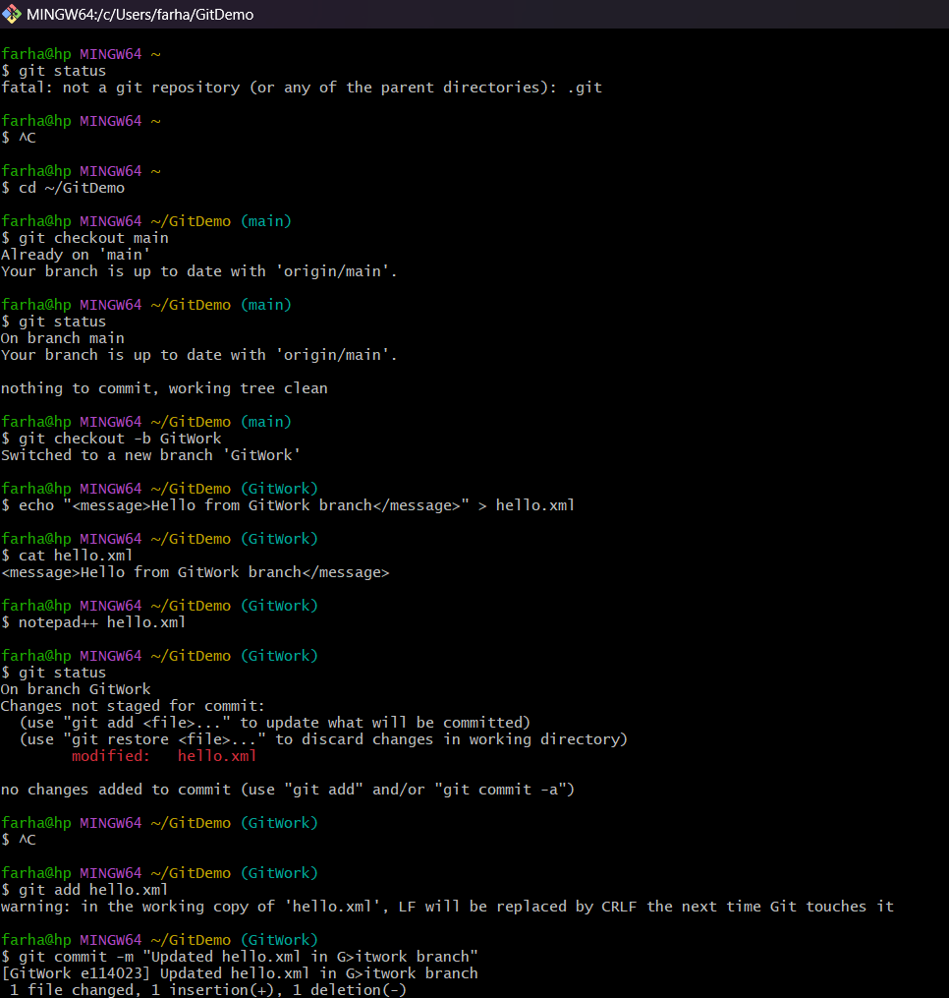**Code:**

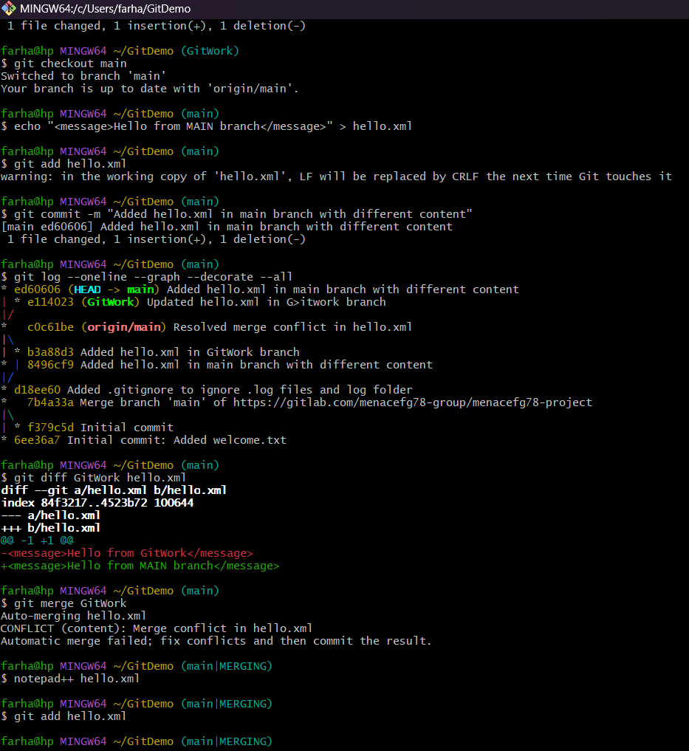

**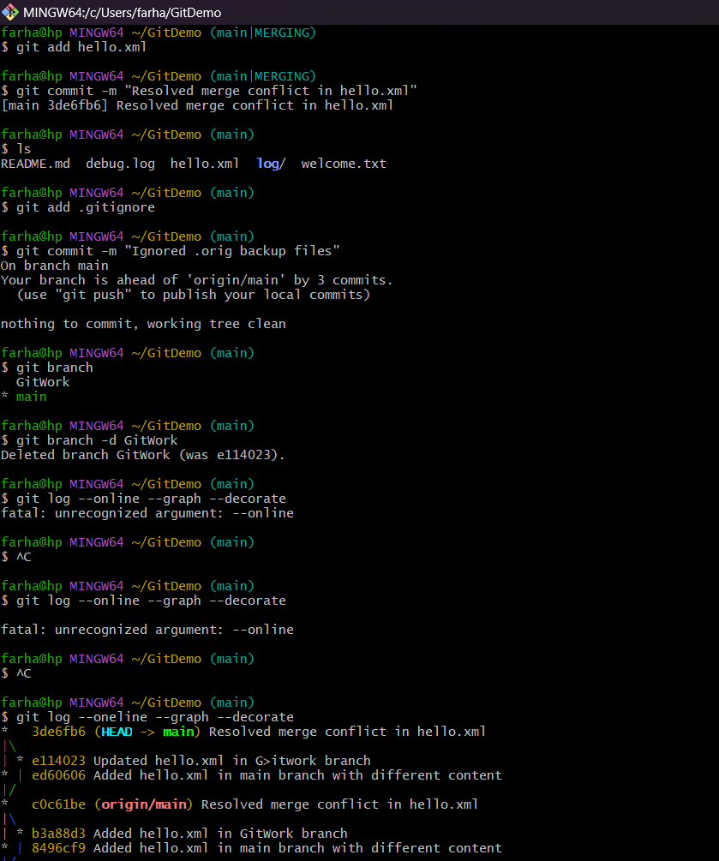  
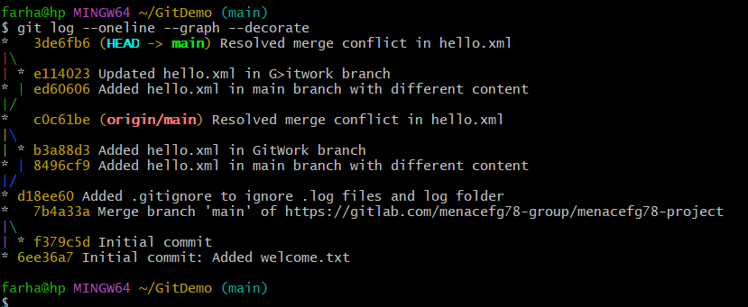**

**Code Text:**

farha@hp MINGW64 ~

$ git status

fatal: not a git repository (or any of the parent directories): .git

farha@hp MINGW64 ~

$ ^C

farha@hp MINGW64 ~

$ cd ~/GitDemo

farha@hp MINGW64 ~/GitDemo (main)

$ git checkout main

Already on 'main'

Your branch is up to date with 'origin/main'.

farha@hp MINGW64 ~/GitDemo (main)

$ git status

On branch main

Your branch is up to date with 'origin/main'.

nothing to commit, working tree clean

farha@hp MINGW64 ~/GitDemo (main)

$ git checkout -b GitWork

Switched to a new branch 'GitWork'

farha@hp MINGW64 ~/GitDemo (GitWork)

$ echo "<message>Hello from GitWork branch</message>" > hello.xml

farha@hp MINGW64 ~/GitDemo (GitWork)

$ cat hello.xml

<message>Hello from GitWork branch</message>

farha@hp MINGW64 ~/GitDemo (GitWork)

$ notepad++ hello.xml

farha@hp MINGW64 ~/GitDemo (GitWork)

$ git status

On branch GitWork

Changes not staged for commit:

(use "git add <file>..." to update what will be committed)

(use "git restore <file>..." to discard changes in working directory)

modified: hello.xml

no changes added to commit (use "git add" and/or "git commit -a")

farha@hp MINGW64 ~/GitDemo (GitWork)

$ ^C

farha@hp MINGW64 ~/GitDemo (GitWork)

$ git add hello.xml

warning: in the working copy of 'hello.xml', LF will be replaced by CRLF the next time Git touches it

farha@hp MINGW64 ~/GitDemo (GitWork)

$ git commit -m "Updated hello.xml in G>itwork branch"

[GitWork e114023] Updated hello.xml in G>itwork branch

1 file changed, 1 insertion(+), 1 deletion(-)

farha@hp MINGW64 ~/GitDemo (GitWork)

$ git checkout main

Switched to branch 'main'

Your branch is up to date with 'origin/main'.

farha@hp MINGW64 ~/GitDemo (main)

$ echo "<message>Hello from MAIN branch</message>" > hello.xml

farha@hp MINGW64 ~/GitDemo (main)

$ git add hello.xml

warning: in the working copy of 'hello.xml', LF will be replaced by CRLF the next time Git touches it

farha@hp MINGW64 ~/GitDemo (main)

$ git commit -m "Added hello.xml in main branch with different content"

[main ed60606] Added hello.xml in main branch with different content

1 file changed, 1 insertion(+), 1 deletion(-)

farha@hp MINGW64 ~/GitDemo (main)

$ git log --oneline --graph --decorate --all

* ed60606 (**HEAD** -> **main**) Added hello.xml in main branch with different content

| * e114023 (**GitWork**) Updated hello.xml in G>itwork branch

|/

* c0c61be (**origin/main**) Resolved merge conflict in hello.xml

|\

| * b3a88d3 Added hello.xml in GitWork branch

* | 8496cf9 Added hello.xml in main branch with different content

|/

* d18ee60 Added .gitignore to ignore .log files and log folder

* 7b4a33a Merge branch 'main' of https://gitlab.com/menacefg78-group/menacefg78-project

|\

| * f379c5d Initial commit

* 6ee36a7 Initial commit: Added welcome.txt

farha@hp MINGW64 ~/GitDemo (main)

$ git diff GitWork hello.xml

**diff --git a/hello.xml b/hello.xml**

**index 84f3217..4523b72 100644**

**--- a/hello.xml**

**+++ b/hello.xml**

@@ -1 +1 @@

-<message>Hello from GitWork</message>

+<message>Hello from MAIN branch</message>

farha@hp MINGW64 ~/GitDemo (main)

$ git merge GitWork

Auto-merging hello.xml

CONFLICT (content): Merge conflict in hello.xml

Automatic merge failed; fix conflicts and then commit the result.

farha@hp MINGW64 ~/GitDemo (main|MERGING)

$ notepad++ hello.xml

farha@hp MINGW64 ~/GitDemo (main|MERGING)

$ git add hello.xml

farha@hp MINGW64 ~/GitDemo (main|MERGING)

$ git commit -m "Resolved merge conflict in hello.xml"

[main 3de6fb6] Resolved merge conflict in hello.xml

farha@hp MINGW64 ~/GitDemo (main)

$ ls

README.md debug.log hello.xml **log**/ welcome.txt

farha@hp MINGW64 ~/GitDemo (main)

$ git add .gitignore

farha@hp MINGW64 ~/GitDemo (main)

$ git commit -m "Ignored .orig backup files"

On branch main

Your branch is ahead of 'origin/main' by 3 commits.

(use "git push" to publish your local commits)

nothing to commit, working tree clean

farha@hp MINGW64 ~/GitDemo (main)

$ git branch

GitWork

* main

farha@hp MINGW64 ~/GitDemo (main)

$ git branch -d GitWork

Deleted branch GitWork (was e114023).

farha@hp MINGW64 ~/GitDemo (main)

$ git log --online --graph --decorate

fatal: unrecognized argument: --online

farha@hp MINGW64 ~/GitDemo (main)

$ ^C

farha@hp MINGW64 ~/GitDemo (main)

$ git log --online --graph --decorate

fatal: unrecognized argument: --online

farha@hp MINGW64 ~/GitDemo (main)

$ ^C

farha@hp MINGW64 ~/GitDemo (main)

$ git log --oneline --graph --decorate

* 3de6fb6 (**HEAD** -> **main**) Resolved merge conflict in hello.xml

|\

| * e114023 Updated hello.xml in G>itwork branch

* | ed60606 Added hello.xml in main branch with different content

|/

* c0c61be (**origin/main**) Resolved merge conflict in hello.xml

|\

| * b3a88d3 Added hello.xml in GitWork branch

* | 8496cf9 Added hello.xml in main branch with different content

|/

* d18ee60 Added .gitignore to ignore .log files and log folder

* 7b4a33a Merge branch 'main' of https://gitlab.com/menacefg78-group/menacefg78-project

|\

| * f379c5d Initial commit

* 6ee36a7 Initial commit: Added welcome.txt

farha@hp MINGW64 ~/GitDemo (main)

$

**Output:**

